Exploiting Parallelism for FPGA Designs

David Robert Clarke

B.Eng Electrical & Electronic Engineering

Dr D.J.Holding

Electrical & Electronic Engineering,
School of Engineering and Applied Science,
Aston University.

05/2001

Project Specification

Aim of Project

To investigate, design and build a FPGA based matrix multiplier, which would be used in alternative serial and parallel matrix multiplication. The system researched will be used to monitor the processing speed difference between the two entities. In the latter stages, partitioning techniques involved in parallel matrix multiplication operations will also be studied.

Objectives

- To Investigate and develop a VHDL scripted algorithm which implements the matrix multiplier

- To investigate various architecture devices

- To Interface the FPGA-based design to a computer monitor

- To stimulate the FPGA design with test signals using a test bench environment

Schedule of Work

- Software

  - To develop a VHDL based design of the matrix multiplier entity and architecture.

  - Study what/how different partitioning techniques on data and investigate how they can be used to get the most productive parallel multiplicative result.

- Research

  - Study into which architectures will give the most effective multiplicative results.

- Interface

  - To investigate how the separate matrices can be inputted from the user and sent to the FPGA-based design.

  - To investigate how the timing data and matrix multiplication results from the FPGA-based design can be outputted and displayed.

4 Test bench

  - To verify that the FPGA-based design behaves accurately.

4.2 Carry out studies to test the full extent the FPGA-based design's processing power.

Acknowledgements

The author would like to thank Dr. D.J.Holding, Mr. M.S.Wrenn and Mr. Robert Cairns for fruitful discussions and comments.

List of Contents

Synopsis Page 5

Introduction Page 6

Body of the Report
- Initial Thoughts Page 7
- System Design Study – The Partition Page 10
- System Design Study – Configuration 1,2 & 3 Page 12
- System Design Study – Configurations Integrated Page 22
- System Design Study – Project 4x4 Page 27
- System Design Study – Project 3x3 Page 29

Conclusion

Reference

Appendices

Synopsis

Introduction

Digital systems design has become an interest of mine since initially studying this subject in the first year of the course. There’s an art to designing digital systems to offer a solution to a specific purpose. The 2nd year developed further my knowledge of digital design, introducing a new design platform VHDL. VHDL is a very high level hardware description language, focused on describing digital systems for the purpose of simulation in tasks such as performance evaluation and design verification. The 2nd year course scraped the surface of the ins and outs, dos and donts of VHDL programming. This project would allow further development of my knowledge of VHDL programming, and allow me to design and generate a unique application specific system.
This project is focused on synthesising digital signal processing subsystems which will target field programmable gate arrays (FPGA’s). Creating a logic circuit for a FPGA usually consists of the following steps (depicted in Figure A):-

- Entering a description of the logic circuit using a hardware description language (HDL) such as VHDL.

- Use a logic synthesizer program to transform the HDL into a netlist. The netlist is just a description of the various logic gates in the design and how they are interconnected.

- Test the functions of the circuit by loading the netlist into a simulator, applying input patterns (known as test vectors), and observing the simulated outputs.

- Use implementation tools to map the logic gates and interconnections into the FPGA. The FPGA consists of an array of slices which can be further decomposed into configurable logic blocks (CLBs) that perform logic operations using a set of look-up tables (LUTs). The CLBs are interwoven with various local and global routing resources.

- Once the implementation is complete, the state of the routing switches and CLBs are extracted to create a bitstream.

- The bitstream is downloaded into a physical FPGA. The electronic switches in the device open or close in response to the binary bits in the bitstream. Upon completion of the downloading, the FPGA performs the operations specified by the HDL code. XILINX Foundation 2.1i provides the HDL editor, logic synthesizer, simulator, implementation tools, and bitstream generator software. The GXSLOAD utility from XESS will download the bitstream into an XS40 FPGA Board.

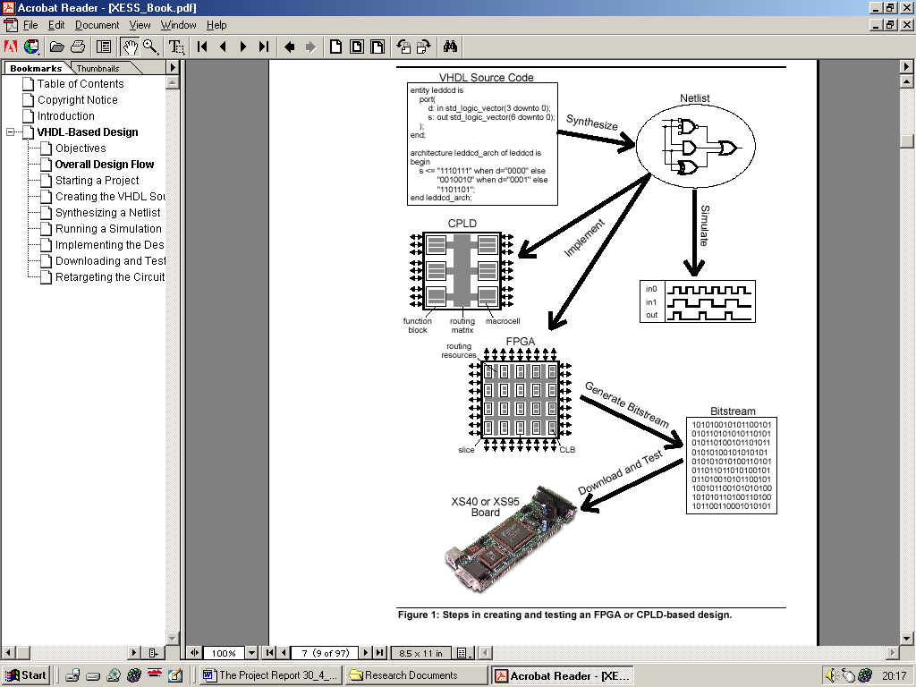

Figure A : Steps involved in creating and testing an FPGA based design

The Body of the Report is split into 6 chapters. The initial chapter delves into the concepts, initial thoughts on the general structure of the design.

Body of the Report

1. Initial Thoughts

Given the title of the project “Exploiting parallelism for FPGA designs,” a number of ideas initially came to mind. Reading further into the project description “to implement computationally intensive algorithms (such matrix multiplication) using essentially sequential data processing techniques.” It became clear from the start, the project would involve developing a system based around the mathematical operation, and non more protracted than that of matrix multiplication. How could parallelism be exploited in a matrix multiplication system? Answer, using parallel processing. Research would need to be undertaken in the issues surrounding matrix computations performed in a parallel system architecture. What test could be undertaken to exploit parallelism? Comparison of a serial DSP architecture against a developed parallel architecture. The key tests would be evaluating processing power (number of clock cycles) required to perform matrix multiplication using either serial or parallel architecture. With the aim of the project loosely in place, the initial design could now be developed.
Serial
Matrix
Multiplicative
Operation

Parallel
Matrix
Multiplicative
Operation
Matrices
Input
Output Answer
Output Operation time

Figure 1.1: Initial High Level Flow Diagram
A high level view of the design was drawn up (shown in Figure 1.1). The design flow shows that given two matrices, by choosing either to process the data in a serial or a parallel fashion, a matrix product will be achieved along with a value for the number of clock cycles required to process the data. Keeping in mind the high level flow diagram, the input, output and processes can be researched in turn.
The mathematics involved in matrix multiplication are simple, but tedious when considering higher order matrices. The Croft Davison Hargreaves “Engineering Mathematics” book explained clearly what was involved in such a matrix multiplication. This information was extracted and inserted into Part 1 of the appendix. The single most important fact, for matrix multiplication to take place the number of columns of matrix A must be the same as the number of rows of Matrix B. With this theory in mind; after the initial flow diagram, a second was drawn up (shown in Figure 1.2) which probes into the separate processes in more detail.
YES
Parallel
Serial
NO
Serial Matrix
Multiplicative Operation

Parallel Matrix
Multiplicative Operation
Output Answer
Output Operation time
Are Matrix A's columns of the same magnitude as Matrix B's rows ?
Produce an error message.
Redefine Matrices.
What method do want to use to find the product?
Input Matrix A's Parameters.
Input Matrix B's Parameters.
Start

Figure 1.2 : Second High Level Flow Diagram
From the start, this digital design would be implemented using the hardware description language, VHDL. Knowledge gained from the 2nd Year VHDL course helped initially in the designs inception, however much was to be learnt about VHDL from this project.
The flow diagram of Figure 1.2 could now be realised initially in block diagram form.
Error_Output
Matrix_Input_A
Matrix_Input_B
Matrix_ B
Matrix _A
DSP_En
Size
Comparator

Finite State Machine
Digital Signal Processing
Output Answer
Output Operating time

FSM_
Enable

Figure 1.3: Very basic system which could implement the matrix multiplication algorithm.

Initial thoughts were, input matrices A and B’s data into the system in a serial fashion (the size of the matrices were not an issue). The first digital system to be met would be the size comparator. Matrix A’s data would be input first, the number of columns would be calculated and stored. Matrix B’s data would then be input, the number of rows would be calculated, stored and then compared against the value of Matrix A’s column size. If the two magnitudes did not match then the data flow would be halted and an error signal would be outputted. The finite state machine is surrounded in a dashed border to illustrate that it isn’t detailed but is involved in the next stage of the data flow process.
The design was becoming too large, too complicated, too fast, hence scraped. To ensure the behaviour of the system could be derived from first principles a simpler specification needed to be supplied.

2. System Design Study – The Partition

- This system would be required to multiply together two matrices. Matrix A and Matrix B would both have the dimensions 2 rows by 2 columns. An example of such matrices that need to be multiplied together are shown below.

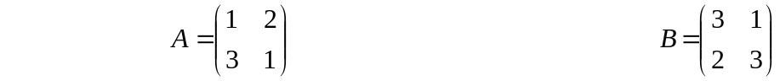
Matrix_A Matrix_B

- The magnitude of each element could not exceed the decimal value 3. Hence each element could be represented by a 2-bit binary number.

Figure 2.1 shows a design created with these ideas in mind. Storage elements such as latches would be required to gather data ready to be passed to the DSP. In this design the latches were looked at a very low level. Routing of signals through the hierarchy of individual latches that made up the storage element Entity was prioritised. The finite state machine would be looked at after the storage element was complete, this wasn’t to be.
Partition
_Out
Clr
Clk
Matrices
_In

FSM
Mem_SEL

Partitioner
Partitioner_En

Memory
(Latches)

DSP
Output Answer

Figure 2.1: Another phase of the Very basic system which could implement the matrix multiplication algorithm.

I had reached a stage where the design model was becoming too low level, emphasis was put on structural design of the individual entities. In the designers mind, structural level based VHDL design would be the only way to implement this design. Again as further designs were developed, this wasn’t to be the case.
The two entities “the controller” and “controlled circuit” would need to be defined and created at a high level. A rethink was required, the system needed to be redesigned. To achieve the aim of the project the top down design methodology needed to kept simple. To keep ideas simple emphasis would need to be placed on the use of behavioural VHDL, this would keep the level of abstraction at a high enough level in order to create the individual digital entities. What the individual entities did, could be described and created. The manner of how the lower level components of the entity are structurally connected was of no concern. With this in mind, a transition to the next step of the design process could be made.

3. System Design Study - Configuration 1,2 & 3

With reference to the aim of the project, the extract “partitioning techniques involved in parallel matrix multiplication” was a major issue when designing this system. To exploit parallelism and partitioning of data in a parallel architecture; through further research a design criteria was thought up, use three different matrix multiplier systems. Individual systems consisting of 2, 4 and 8 multipliers would be implemented. Indeed more multiplier configurations could be implemented i.e. >4, or even two, however, three systems would show results consisting of low, medium and high levels of processing.
Going back to basics, the system would consist of

FSM Controller - FSM which enables logic functions to operate

DSP - the DSP alters the signal, i.e. processes the signal so it is in a different form

Inputs - Two matrices, Matrix A has 2 columns by 2 rows, Matrix B also has 2 columns by 2 rows. The magnitude of each element is known as shown below.

This data would be serially input into three different ASM controllers. Each ASM controller would operate in one of three ways:-

- Configuration one would comprise of an individual ASM Controller and DSP, the DSP would consists of two multipliers.

- Configuration two would comprise of an individual ASM Controller and DSP, the DSP would consist of four multipliers.

- Configuration three would comprise of an individual ASM Controller and DSP, the DSP would consist of eight multipliers.

Shown below is a very high level view of how the three processors would look:
ASM Controller
Matrix Input
Matrix Multiplication
Answer calculated in time T1
Matrix Multiplication
Answer calculated in time T3
DSP (2xMultiplier)
ASM Controller
DSP (4xMultiplier)
ASM Controller
DSP (8xMultiplier)
Matrix Multiplication
Answer calculated in time T2

Figure 3.1: Highest level Look at the Matrix Multiplier Configurations

Some questions might obviously be raised. Why are three separate configurations being tested?

Answer: If three configurations were culminated into one ASM controller with one DSP, there could be some problems. Firstly the single ASM controller and DSP would have logic (which is redundant for some configurations and active for others) this extra logic could unheedingly slow down the processing of data . Hence the processing time results would be difficult to differentiate for the three different configurations.
Having three processors working on the data at the same time would show in one sitting will show what the difference in the processing speeds are. There would be no need to re-enter the matrix data for a second or third time in order to calculate the Matrix product for a different configuration. The three configurations are shown in more detail in Figures 3.2, 3.3 & 3.4.

Matrix A
Data Element
Matrix B
Data Element
Matrix B
Data Element
Matrix A
Data Element
A(2)xB(1) + A(3)xB(3)
A(2)xB(0) + A(3)xB(2)
A(0)xB(1) + A(1)xB(3)
A(0)xB(0) + A(1)xB(2)
TWO 4-BIT DATA BUSES HOLDS MATRIX DATA ELEMENT PRODUCT
8-BIT
Elemental Data Bus
Matrix A and Matrix B data

2-BIT
MULTIPLIER
MULTIPLIES TOGETHER TWO SETS OF MATRICES ELEMENT DATA BITS TO FORM THE MATRIX DATA ELEMENT PRODUCT

4-BIT
ADDER
THE MATRIX DATA ELEMENT PRODUCT WORDS ARE ADDED TOGATHER

MEMORY
STORES FOUR SETS OF SUM-OF PRODUCTS
5-BIT DATA BUS HOLDS SOP AND PRODUCTS
ALLOCATE DATA TO MEMORY LOCATION 1, 2, 3 OR 4

2-BIT
MULTIPLIER
MULTIPLIES TOGETHER TWO SETS OF MATRICES ELEMENT DATA BITS TO FORM THE MATRIX DATA ELEMENT PRODUCT

FSM CONTROLLER
CONFIGURATION_1
D-TYPE CLOCKING SIGNAL 4-BITS, WHEN LOW to HIGH, DATA at D IS STORED

Figure 3.2: Configuration 1, parallel processing system containing 2, 2-bit multipliers and a 4-bit adder

Matrix A and Matrix B
Data input
Matrix B
Data Element
Matrix B
Data Element
Matrix A
Data Element
Matrix A
Data Element
Matrix B
Data Element
Matrix A
Data Element
Matrix B
Data Element
Matrix A
Data Element
A(2)xB(1) + A(3)xB(3)
A(2)xB(0) + A(3)xB(2)
A(0)xB(1) + A(1)xB(3)
A(0)xB(0) + A(1)xB(2)
FOUR 4-BIT DATA
16-BIT
Elemental Data Bus

2-BIT
MULTIPLIER

4-BIT
ADDER

MEMORY
STORES FOUR SETS OF SUM-OF PRODUCTS
TWO 5-BIT DATA BUSES HOLD SOP AND PRODUCTS

FSM CONTROLLER
CONFIGURATION_2

2-BIT
MULTIPLIER

2-BIT
MULTIPLIER

2-BIT
MULTIPLIER

4-BIT
ADDER

D-TYPE CLOCKING SIGNAL, WHEN LOW to HIGH, DATA at D IS STORED

Figure
Figure 3.3: Configuration 2, parallel processing system containing 4, 2-bit multipliers and 2, 4-bit adder
EIGHT 4-BIT DATA BUSES
D-TYPE CLOCKING SIGNAL 4-BIT,WHEN LOW to HIGH, DATA at D IS STORED
Matrix A
Data Element
Matrix B
Data Element
Matrix B
Data Element
Matrix A
Data Element
Matrix A
Data Element
Matrix B
Data Element
Matrix A
Data Element
Matrix B
Data Element
Matrix A
Data Element
Matrix B
Data Element
Matrix A
Data Element
Matrix B
Data Element
Matrix A
Data Element
Matrix B
Data Element
Matrix B
Data Element
Matrix A
Data Element
A(2)xB(1) + A(3)xB(3)
A(2)xB(0) + A(3)xB(2)
A(0)xB(1) + A(1)xB(3)
A(0)xB(0) + A(1)xB(2)
32-BIT
Elemental Data Bus
Matrix A and Matrix B data serially Inputted
2-BIT
MUL

4-BIT
ADDER

MEMORY
STORES FOUR SETS OF SUM-OF PRODUCTS
FOUR 5-BIT DATA BUSES HOLD SOP AND PRODUCTS

FSM CONTROLLER
CONFIGURATION_3
4-BIT
ADDER

2-BIT
MUL

2-BIT
MUL

2-BIT
MUL

2-BIT
MUL

2-BIT
MUL

2-BIT
MUL

2-BIT
MUL

4-BIT
ADDER

4-BIT
ADDER

ALLOCATE DATA TO MEMORY LOCATION
1, 2, 3 OR 4

Figure 3.4: Configuration 2, parallel processing system containing 8, 2-bit multipliers and 4, 4-bit adder
How would the matrices data enter these configurations?

Data could easily be shifted in a serial manner then acted upon by the DSP (the matrix multiplier). Because the whole purpose of this project rested on the aspect of exploiting parallelism, data should also exploit this. So the matrices data would arrive at the input to the DSP in parallel, but where from? The easiest method, the method which was adopted, was the use of a memory element (ROM) prior to the DSP. In the realisation of this entity, data control signals would be sent from the ASM CONTROLLER to the memory module. Data in this memory module would then be placed on the data bus when required. To visualise the operation of the Configuration system so far, a schematic has been developed in Figure 3.5.
ELEMENT DATA BUS
unsigned (X downto 0)

DATA SELECT SIGNAL
Integer range (X downto 0)
LATCH_MEM SIGNAL
std_logic_vector
(X downto 0)
CLR

CLK

ASM CONTROLLER
CONFIGURATION_X

DSP

MEMORY
BLOCK
A0B0_A1B2
std_logic_vector
(4 downto 0)
A0B1_A1B3 std_logic_vector
(4 downto 0)
A2B0_A3B2
std_logic_vector
(4 downto 0)
A2B1_A3B3
std_logic_vector
(4 downto 0)
Figure 3.5: High Level Abstraction of the Configuration System
All of the proceeding simulation test results were obtained on the Xilinx Foundation 2.1i simulator. The matrix test vectors (stated on page 14) were stored in a memory block for each individual Configuration. By clocking the system, the controller would select the matrix data to be input to the DSP where the data would be stored and the simulated outputs observed.

Configuration 1 Testing
The simulation results for Configuration_1 are shown in Figure 3.6. The VHDL script that describes the structure of its architecture can be found in the appendix of this report.
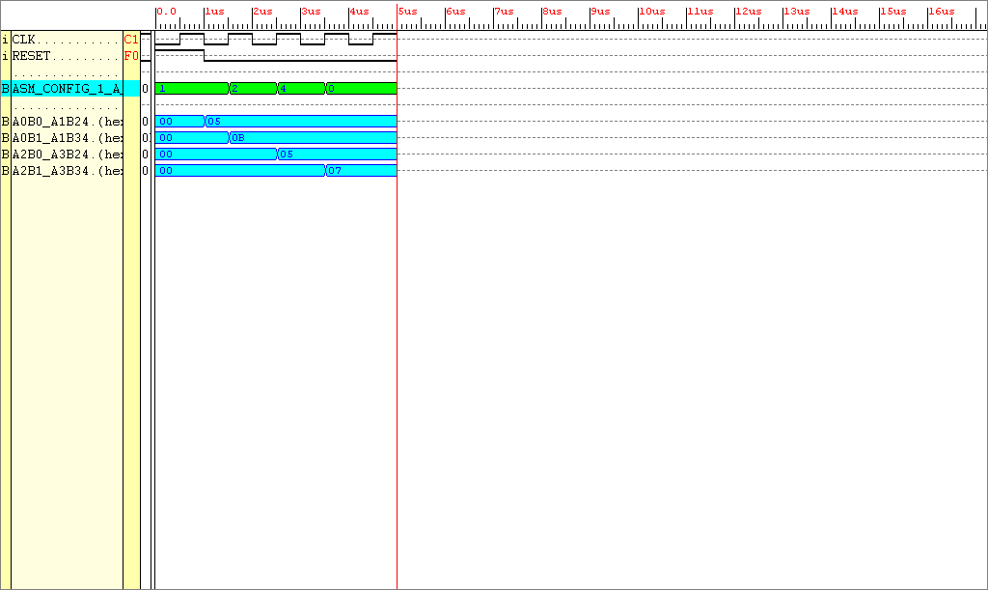
Figure 3.6: Simulation results achieved by Entity Configuration_1

Figure 3.6 shows Configuration 1 in full operation. In accordance with the state of the system, an elemental matrix product is produced which is output to the correct set of 5bit memory elements. These are marked down on the simulation above as A0B0_A1B2 to A2B1_A3B3.
For the matrix multiplication to complete, four clock cycles are required.

Configuration 2 Testing
The simulation results for Configuration_2 are shown in Figure 3.7. The VHDL script that describes the structure of its architecture can be found in the appendix of this report.
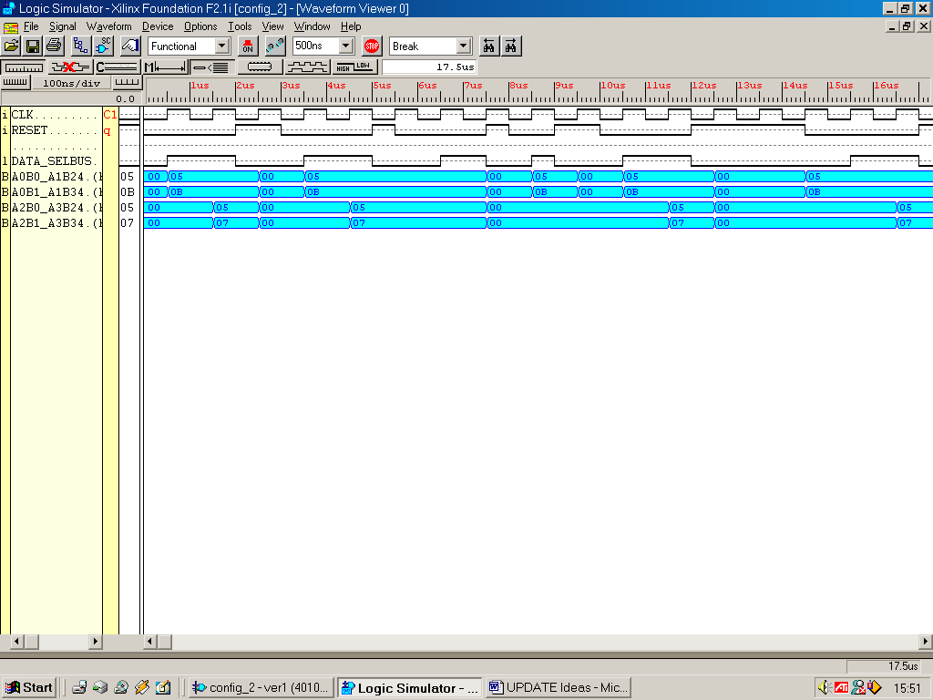
Figure 3.7: Simulation results achieved by Entity System_2.

In the first state half the data required for the matrix product is selected to be entered onto the data bus using the select signal “Data_Select.” 10bits of answer memory are enabled using the select signal “Mem_Sel_Out.” In the second state, both select signals go low, the second half of data is placed onto the data bus. The final data bits are placed onto the data bus, the DSP acts upon these data bits to create the matrix product for the last two elements. For the matrix multiplication to complete, two clock cycles are required.

Configuration 3 Testing
The simulation results for Configuration_2 are shown in Figure 3.8. The structure of ENTITY Configuration_3 is placed in the appendix of this report.
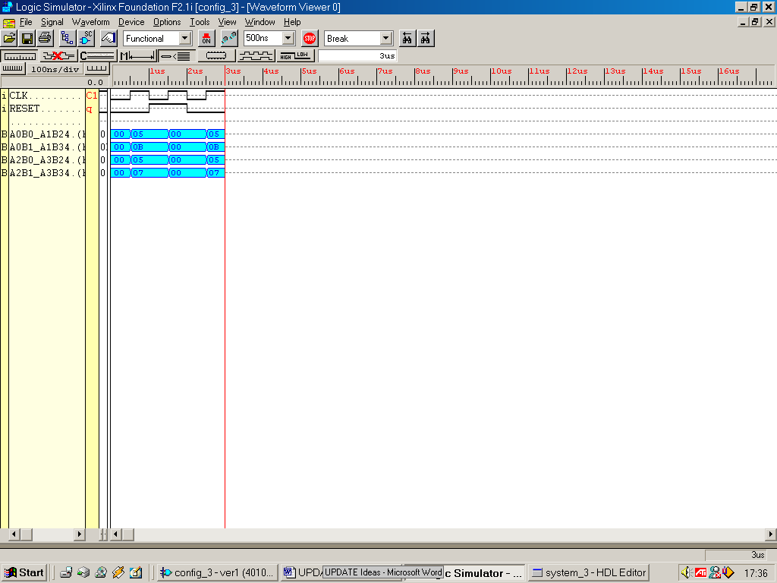
Figure 3.8 : Simulation results achieved by Configuration_3

Configuration 3 had a much bigger DSP structure than the previous configurations. This system didn’t require much in terms of control signals from the finite state machine to make it operate. To complete the two, 2x2 matrix multiplication, the data was entered straight onto the data bus, input to the DSP. Configuration 3’s DSP handled all the arithmetic operations on all the matrix data, allowing the matrix product to be stored without any further calculations. The individual components were not tested here, however the full system was.
A large number of steps were involved in creating the 3 initial Configurations. The three configurations operated fine individually. Collective testing would be required, creating a system which would shows in one test cycle, the results of exploiting parallel architectures. This system that would encompass the three configurations collectively, running from a single common clock, the design would be called Configurations 123. The simulation results of such an entity were produced and pasted on Page 23.

Configurations_123 Testing

To observe the structural VHDL of ENTITY Configuration_3 look in the appendix of this report.
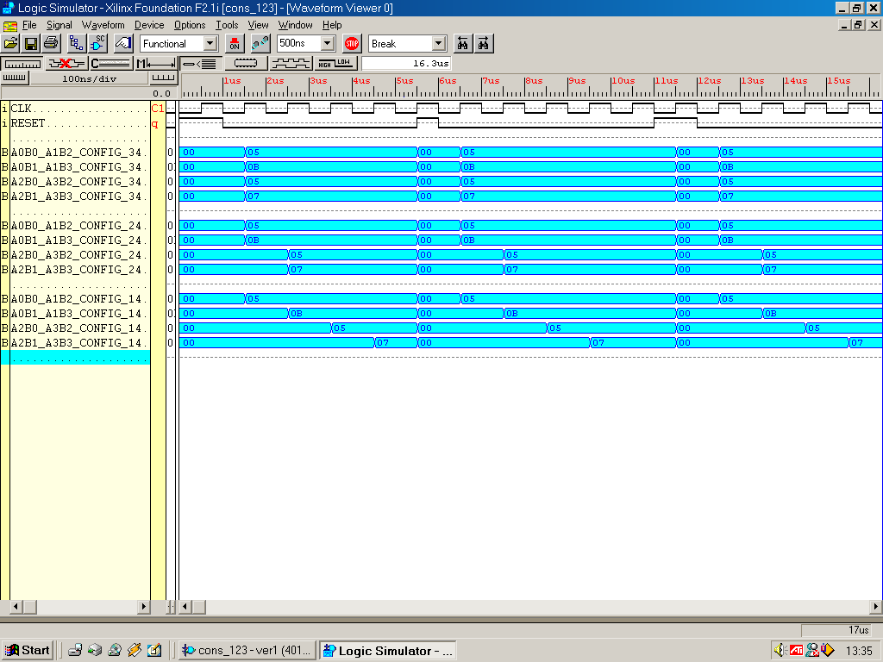
Figure19: Simulation results achieved by ENTITY Systems_123

The results are shown above in blue, Configuration_3 results are shown in the four uppermost blue bands, Configuration_2 results are shown in the middle set of bands and Configuration_1's results are shown in the bottom blue band. The system must always be initially RESET to initialise the current state. These results clearly show the advantage of having a parallel architecture. Configuration_1, Configuration_2 & Configuration_3 completed the matrix multiplication in 4, 2 & 1 clock tick(s) respectively.
The next step after the process of design, synthesis and simulation is implementation. The target hardware for the design is a Xilinx XC4010XL PC84 FPGA. Using the Xilinx Foundation Series 2.1i software, the implement process (shown in Figure A) was undertaken, mapping the logic gates and interconnections into the FPGA. However the ENTITY Configurations_123 could not be placed and routed because all the external IOB’s were used up (not enough pins). A solution would be to culminate the separate configurations into one ASM controller ,DSP and Data_Store that can be set up to perform the operation of the separate configurations.
The whole system operated correctly in simulation, but could not fit onto the target FPGA due to the masses of large buses required by the system. If the system was integrated, with an emphasis on bus re-use, could the system be built efficiently to give the correct results?
4 System Design Study - Configurations Integrated

Design Thoughts
ASM Controller- Integrate the ASM controllers into one Architecture. Only one configuration would be able operate at any one instant. Hence the amount of states required to justifiably create this would have the accumulative amount of states of the three individual configurations.

Memory Block - Integrate all the memory elements into one large ROM, remembering to use different processes for the different Configurations.

DSP - If the amount of multipliers and adders are kept to that used in configuration_3 all configurations can be accounted for, saving valuable extra buses in the process. However, the ENTITY memory must be changed in order to allow for 3 different types of SOP output.

Note the answer storage must operate (in total) 7 different ways to account again for the separate configurations. For example store answer using 20, 10 or 5 of answer memory. The required select signal needs to be 3 bits wide to cater for these seven operations. With these thoughts in mind the initial integrated configurations can now be visualised.

To give the VHDL script a more accessible layout, a package was produced. The finalised package is placed in the back of this report.

ON A 20-BIT BUS WHICH ENTERS THE ANSWER STORAGE

DATA SELECT SIGNAL
Integer range (6 downto 0)
MEMORY SELECT
SIGNAL 3-BITS WIDE
Matrix A
Data Element
Matrix B
Data Element
Matrix B
Data Element
Matrix A
Data Element
Matrix A
Data Element
Matrix B
Data Element
Matrix A
Data Element
Matrix B
Data Element
Matrix A
Data Element
Matrix B
Data Element
Matrix A
Data Element
Matrix B
Data Element
Matrix A
Data Element
Matrix B
Data Element
Matrix B
Data Element
Matrix A
Data Element
A(2)xB(1) + A(3)xB(3)
A(2)xB(0) + A(3)xB(2)
A(0)xB(1) + A(1)xB(3)
A(0)xB(0) + A(1)xB(2)
32-BIT
Elemental Data Bus
2-BIT
MUL

4-BIT
ADDER

ANSWER
STORE
STORES FOUR SETS OF SUM-OF PRODUCTS
FOUR 5-BIT DATA BUSES HOLD SOP. THIS DATA IS THEN PLACED

ASM CONTROLLER

4-BIT
ADDER

2-BIT
MUL

2-BIT
MUL

2-BIT
MUL

2-BIT
MUL

2-BIT
MUL

2-BIT
MUL

2-BIT
MUL

EIGHT 4-BIT DATA BUSES
4-BIT
ADDER

4-BIT
ADDER

DATA
STORE
ALLOCATE DATA TO MEMORY LOCATION
1, 2, 3 OR 4
S 3bits
Configuration Mode Select

Figure20 : High Level Abstraction of the Configuration Integrated System
Shown below is some arbitrary test data used on the system
2
1
0
1
1
2
1
0

MATRIX_1 MATRIX_2

The multiplication and addition operations performed will be :-

(2 x 1) + (1 x 1) = 2 + 1 = 3
(2 x 2) + (1 x 0) = 4 + 0 = 4
(0 x 1) + (1 x 1) = 0 + 1 = 1
(0 x 2) + (1 x 0) = 0 + 0 = 0
3 4 1 0

The whole system will now be tested. The behaviour model of ENTITY Whole_System and the DSP (which is incorporated in the Whole_System) can be viewed in the appendix of this report.

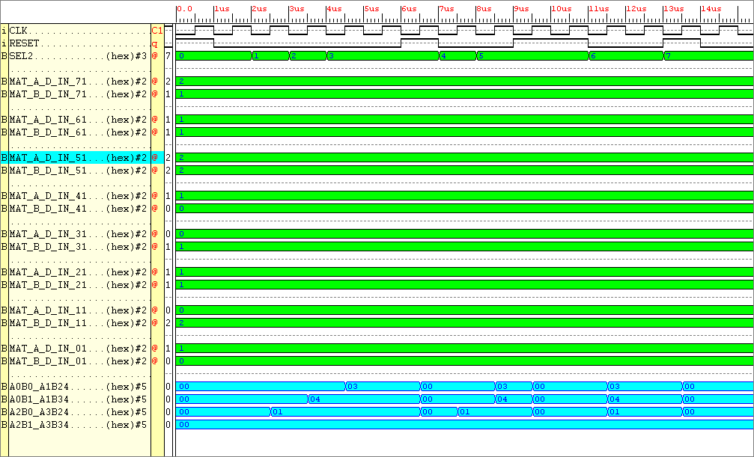
Figure26 : Simulation results for the Entity Whole System

Observe the results at the bottom of the figure in blue (these are the outputs from the DSP). The answers calculated on page 20 correlate exactly with the simulation results in Figure26. The results span over seven states. In mode Configuration 1 output an answer take 4 cycles, whilst the faster Configuration 3 only takes one cycle. Each set of results are separated by a RESET, so that the next multiplication mode’s outputs can be seen (the results obtained in all three modes are the same, without a zeroing of the output signals, the calculated values on the outputs would not be seen).
Using the Xilinx Foundation Series Software, the design could now be implemented. The FPGA place and routing software, without error, produced files which contained all the data required to program the FPGA. By using the program Floorplanner within the Xilinx Foundation suite, the structure of the design within the FPGA could now be viewed.

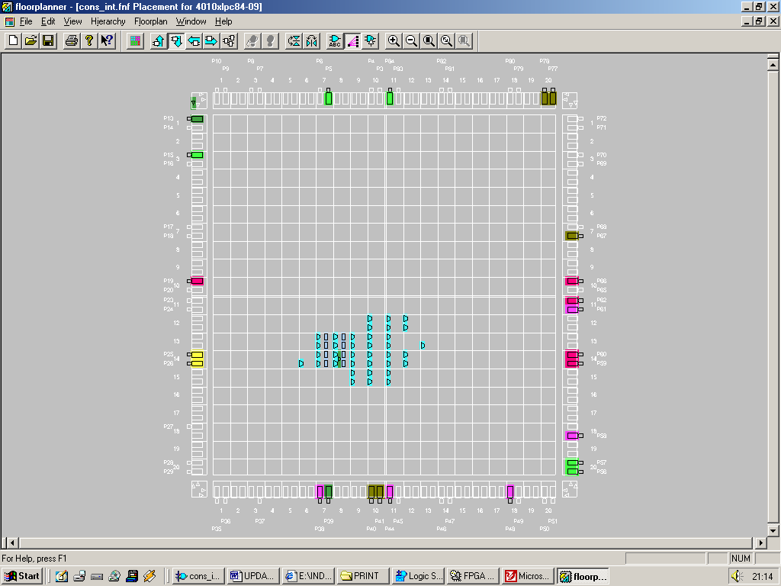
Figure27 : Design structure of the integrated Configurations within the FPGA

The floorplan view of the design clearly shows it can clearly be routed and programmed in the FPGA. Now that that this simple system works (simulates and can be placed and routed) a few things can be done to increase the complexity of the design. Still keeping with the format “the maximum magnitude of a matrix element is 3”, by upping the size of the matrix data. The ENTITY DATA_STORE will need to include more data, the multipliers and adders can be kept in tact ENTITY ANSWER_STORE will need to be more complex in order to store more data, also the ASM_CONTROLLER will require more states and steering logic. Using this design as a base to work from, the complexity of the system can be increased to handle larger matrices.

5. System Design Study - Project 4X4

At the end of the day this system is used to process matrix data, in this case 4x4 matrices. Shown below is an example of data required to be tested on the completed system.
2
3
3
1
1
2
1
3
2
1
2
1
2
2
2
1
2
1
3
1
1
2
2
3
1
2
1
3
3
1
0
2

MATRIX_A MATRIX_B

Shown below is the full set of hand calculations required to generate the matrix product of two 4x4 matrices.

(2 x 1) + (3 x 1) + (2 x 1) + (1 x 1) = 8
(3 x 1) + (1 x 1) + (2 x 1) + (1 x 1) = 7
(2 x 1) + (2 x 1) + (2 x 1) + (1 x 1) = 7
(2 x 1) + (1 x 1) + (3 x 1) + (1 x 1) = 7

(2 x 2) + (3 x 3) + (2 x 2) + (1 x 3) = 20
(3 x 2) + (1 x 3) + (2 x 2) + (1 x 3) = 16
(2 x 2) + (2 x 3) + (2 x 2) + (1 x 3) = 17
(2 x 2) + (1 x 3) + (3 x 2) + (1 x 3) = 16

(2 x 1) + (3 x 2) + (2 x 3) + (1 x 0) = 14
(3 x 1) + (1 x 2) + (2 x 3) + (1 x 0) = 11
(2 x 1) + (2 x 2) + (2 x 3) + (1 x 0) = 12
(2 x 1) + (1 x 2) + (3 x 3) + (1 x 0) = 13

(2 x 2) + (3 x 3) + (2 x 1) + (1 x 2) = 17
(3 x 2) + (1 x 3) + (2 x 1) + (1 x 2) = 13
(2 x 2) + (2 x 3) + (2 x 1) + (1 x 2) = 14
(2 x 2) + (1 x 3) + (3 x 1) + (1 x 2) = 12

Mentioned below is a summary of the problems encountered by the system through different evaluation methods.
The system is far too big for generous evaluation. The DSP itself has far too many Inputs/outputs to test. This device would require a total of 96 outputs, that is 96 pins, the FPGA only has 65 free. Excluding the clk, reset, mode select pins, the number of pins available are:-
CLK = 1 BIT
RESET = 1 BIT
MODE SELECT = 3 to 6 BITS
OUTPUT = (65 – 8) = 57

From the implementation reports 290 complex logic blocks out of the total 400 are used in the DSP of the 4x4 matrix multiplier. With the remaining 110 CLB’s, the FSM needs to be constructed. This is a good amount to work with, however there is a lot of data manipulation required of the finite state machine in order to create the matrix product.
A good way to output the data would be to have 34 seven segment displays placed onto a PCB (34 including the two seven segment displays which are used to output the number of cycles required to obtain the answer). Each seven segment display would require at a minimum an 8-bit flip flop. The flip flop would be used store the answer in each element. The finished output system would comprise of a board with 34 seven segment displays plus 34 flip flops. This board will need to be designed in the PCB program Areslite, once the designs have been finalised. To output the matrix product from the FPGA to the seven segment displays in one cycle would require 16 x 7 segment displays = 112 pins. This is not viable, however outputting the data for two seven segment displays is, requiring only 14 output pins. However 17 enable signals would be required in order to select the correct set of seven segment displays. Hence a total of 31 output pins would be required out of the 57 available, this hasn’t taken into consideration data inputting to the system.
An idea would be to use the vacant external SRAM chip available on the XS40 board, this has an 8-bit output. It requires eight clock cycles to get 64-bits of data onto the Elemental data bus. However the process required to do this is far from simple, using the RAM chip also rules out use of a number of pins available on the FPGA. Another method of inputting data is required.
After some serious thought, to output the product of two 4x4 matrices would require too many FPGA complex logic blocks which are simply not available. Testing and verifying data by hand is too cumbersome. The output matrix PCB would be far too big.

6. System Design Study - 3x3 Matrix Project

After ruling the out the requirement for a matrix multiplier that multiplies two 4x4’s what can be done however is to produce a system that produces the product of two 3x3 matrices. Producing the DSP that will calculate the matrix products would be a simple task, because it is a scaled down version of the 4x4 matrices. Another problem to overcome was data input, the thought of using the onboard RAM on the XS40 board was an option, but the procedure required to access it seems too complex a task. A better way would be to use a program which is part of XSTOOLS (a program available for the XS40 board) which allows a windows based simulation program that allows data to be input to the board through the parallel port in eight-bit quantities.
A13
A23
A11
A12
A21
A22
A31
A32
A33
B13
B23
B11
B12
B21
B22
B31
B32
B33

MATRIX_A MATRIX_B
Figure28 : Mathematical representation of the matrices

(A11 x B11) + (A12 x B21) + (A13 x B31)
(A21 x B11) + (A22 x B21) + (A23 x B31)
(A31 x B11) + (A32 x B21) + (A33 x B31)

(A11 x B12) + (A12 x B22) + (A13 x B32)
(A21 x B12) + (A22 x B22) + (A23 x B32)
(A31 x B12) + (A32 x B22) + (A33 x B32)

(A11 x B13) + (A12 x B23) + (A13 x B33)
(A21 x B13) + (A22 x B23) + (A23 x B33)
(A31 x B13) + (A32 x B23) + (A33 x B33)

By looking at the methodology for solving a 3 x 3 matrix it can be seen that 27 multiplications are involved. Also for every 3 multiplication operations 1 adder is required.

NUMBER OF MULTIPLIERS REQUIRED = 27
NUMBER OF ADDERS REQUIRED = 9

There are 18 elements involved in a 3x3 by a 3x3 matrix multiplication, each element is limited to a 2-bit value hence

BITS OF INPUT DATA = (No. of elements in MATRIX_A + No. of elements in MATRIX_B) x (Bit width magnitude of a elements data)
BITS OF INPUT DATA = ((3x3 )+ (3x3)) x 2 = 36 bits

If all the elements had a magnitude of 3 (highest case) then the magnitude of an element of the product matrix would be

(A11 x B11) + (A12 x B21) + (A13 x B31)
(3 x 3) + (3 x 3) + (3 x 3)
9 + 9 + 9 = 27, twenty seven in binary is 11011, which is 5-bits wide

The magnitude of each matrix elements product would be 5-bits, there are 9 products, hence the answer would be 45-bits wide.

In the previous Integrated Configuration system data was stored in the system in a block of ROM. This block of ROM cannot be written to, the input data held once created cannot be altered. To fulfil an aim, it would be allot more satisfying for the user to input his or her own matrices data. As explained earlier, this can be done by inputting data using the parallel port cable into the FPGA. But how will the data be stored in the FPGA?

By using a program called WinXSport, data can be downloaded to the XS40 board through the PC Parallel port. Eight bits of data can be downloaded at any one time.

There are 36 latches available to send data to, the correct set of latches needs to be selected, hence in the byte of data is latch select information. What can be done is, send data in nibbles, which leaves 4-bits remaining to select which set of latches the data needs to be sent to. 36-bits of data needs to be sent to the latches in total, 4-bits of data can be sent per cycle, hence 9 data cycles are required to send the 36-bits of data. 9 different select signals, a 4-bit select signal is required to coordinate the data destination. Hence:-
In the byte of data sent from the WinXsport program there are:-

- 4-bits of signal select
- 4-bits of data

Hence the ENTITY DATA_STORE will have a 8-bit input, 4bits used to input data the remaining 4bits selects the correct latches of the entity input. There is a 36-bit matrix data output that handles the answer output. Problem, From simulating the initial system (VHDL script withheld from the report) the output of latches refuse to reset. Solution, have a clock input on the PC Parallel port data byte, have 4-bits of that byte devoted to flip flop (not latch) selection, 1- bit of the byte devoted to a clock signal, and the remaining 3-bits devoted to data transfer. Lets look at the wider implications of this new entity design. In the byte of data sent from the WinXsport program there are:-

4-bits of signal select
1-bit parallel port clock signal
3-bits of data

Hence the ENTITY DATA_STORE
INPUT : 3-bits input data
1-bit clock input
4-bits select input
OUTPUT: 36-bit matrix data output

There will be 36 D-type flipflops involved in the data transfer, if the rising edge of the clock signal occurs, dependant on the select signal, 3-bits of input data is transferred to the output of three flip-flops. Hence 12 clock ticks are required in order to get all the data onto the Elemental Data Bus as opposed to 8, as in the previous design. Here’s how data will look on the parallel port WinXsport program interface.

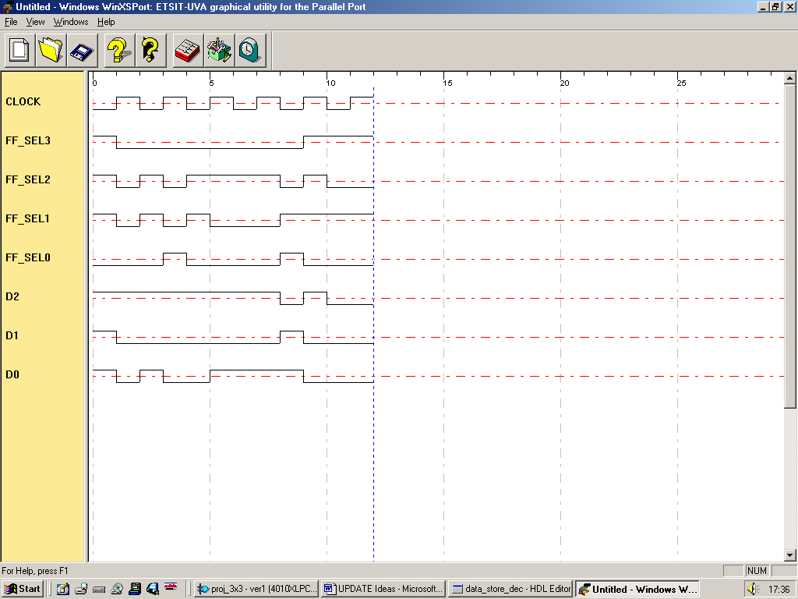
Figure 29: Screen capture from the XS40 simulation tool WinXSport showing clock, select and data signals

The Data Store algorithm will now be created which will allow (stable) flip flops to be used in place of (unstable) latches. The behaviour model of ENTITY Data_Store can be viewed in the appendix of this report.

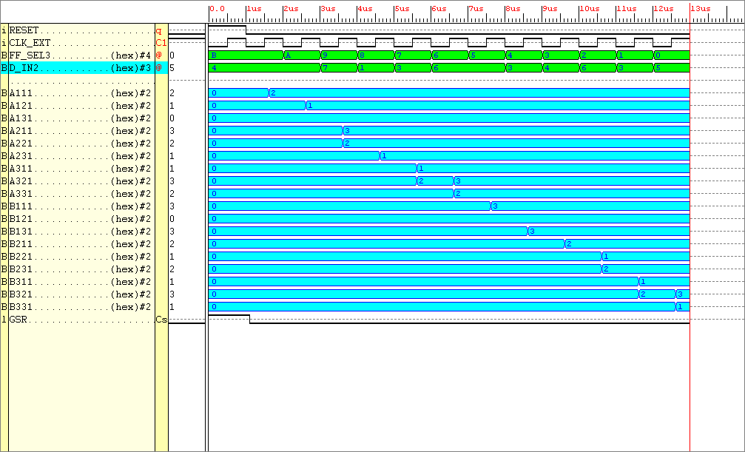
Figure30 : Simulation results for the new clock driven Entity Data_Store

Observing the data above it can be seen that (governed by the external clock “clk_ext”) the correct data is outputted from the system. The data in D_IN is 3-bits wide, it is at a value of 7 for this simulation (binary “111”), using the 12 select signals “FF_SEL” the data goes to the correct set of flip-flops.

There were 2 WARNINGS inferred when implementing (software place and routing) the synthesised model. After visiting the Xilinx website it was clear that these warnings were caused by a software fault. However the system behaved correctly. Notice there is no RESET input signal. This hasn’t been implemented mainly due to lack of pins on the parallel port. A reset will need to be implemented in later designs.
The implementation report indicates that this entity only requires 6 complex logic blocks, there are 400 available, hence this is a very small part of the overall system. In order to output data from the Entity “Data_Store” of type unsigned, the input data must also be of the unsigned data type. Cannot convert an object of STD_LOGIC_VECTOR into UNSIGNED, SIGNED, INTEGER type. Now the next process can be completed.

The entity used to multiply two 3x3 matrices requires 27 two input (2bit) multipliers. With each multiplier assigned it’s own unique combination of the input matrices elements. Lower order matrices can be multiplied together using this same architecture, however some of the multipliers will be redundant in this case. The behaviour model of ENTITY Data_Store can be viewed in the appendix of this report.
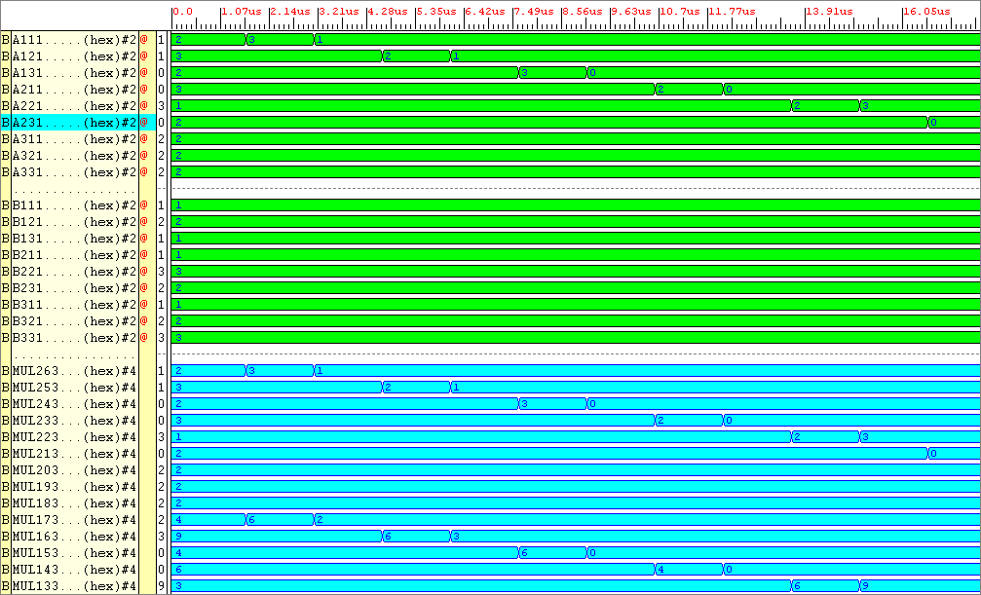
Figure31 : Simulation Results for the entity Multipliers

The A and B inputs (shown as a green waveform) are indexed from 11 to 33. For example, A11 refers to Matrix A, element position row 1, column 1.. The output waveform Mul26 (there are 27 multiplications involved in a 3x3 matrix product answer) refers to the very first product A11 x B11 (Mul0 is the last, but is not shown) shown in the simulation results. Page 42 shows the other 26 multiplications needed to produce the products ready for the adder section of the DSP to sum. The matrix B element coefficients were kept constant (at a value in the range 0 to 3) whilst the Matrix A values were altered. The answers achieved by the entity were true to the behavioural VHDL design. Knowing the entity performed true to it’s design it was then placed and routed using the Xilinx Foundation Software. This allowed further analysis such as FPGA routing constraints, and physical size determination. The multiplier entity required 54 complex logic blocks.

The adder entity will require 9 adders which consist of 3, 4bit inputs and 9, 5bit outputs. This allows all the products produced by the multiplier entity to be summed resulting in the matrix product. A very high level behavioural adder model is used, there is a concatenation operator which allows the carry bit to be produced. The behaviour model of Entity Adders can be viewed in the appendix of this report.
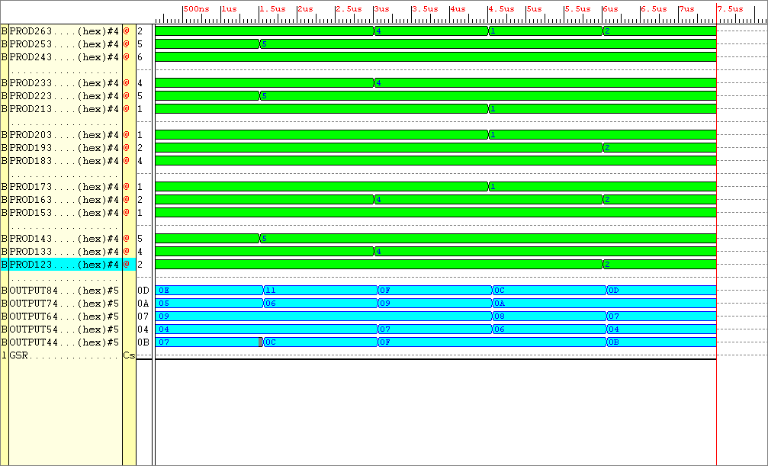
Figure32 : Simulation results from ENTITY Adders

To simulation results of Figure32 can easily be evaluated. Not all the inputs and outputs are shown here. The additions required are divided into groups of three, OUTPUT8 corresponds to the sum of the first set of three numbers, OUTPUT7 corresponds to the output of the second set of sums and so on. The outputs shown in blue at the bottom of the simulation results are in hexadecimal format. The first three additions at inputs PROD 26 downto 24 produced the answer “OE” at Output8, which corresponds to a decimal value of 14. Knowing the entity performed true to it’s design it was then placed and routed using the Xilinx Foundation Software. This allowed further analysis such as FPGA routing constraints, and physical size determination. The multiplier entity required 51 complex logic blocks.

The final part of the DSP which is used to store the outputted data is an Entity called Answer_Store. This entity just outputs what’s on it’s inputs on the clock edge, when enabled.
The behaviour model of Entity Answer_Store can be viewed in the appendix of this report.

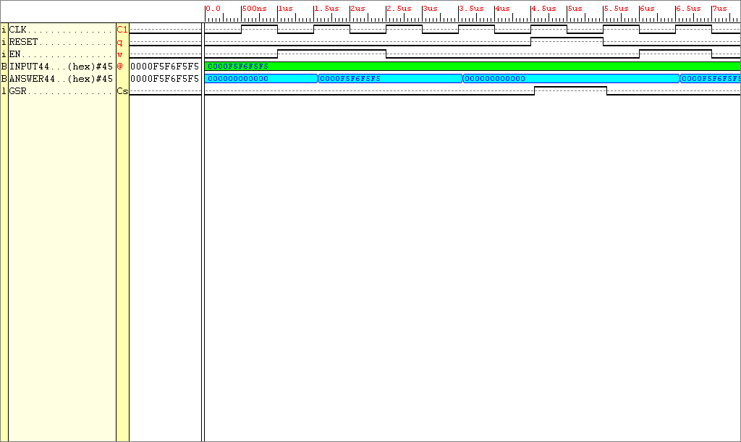
Figure33: Simulation results taken from entity Answer_Store

Because the signal Enable needs to be tied down to a particular value, it does act like a RESET signal. This however will not affect the behaviour of the system too much, the enable signal will just have to be kept high through the process of generating an answer. Once the data is stored on the board with the seven segment displays, the enable signal can then be taken off. Knowing the entity performed true to it’s design it was then placed and routed using the Xilinx Foundation Software. This allowed further analysis such as FPGA routing constraints, and physical size determination. The adders entity required 23 complex logic blocks. The DSP is completed up to a point, further processing is required in order for the matrix product answer to be outputted to the seven segment displays (more on this later).
A mechanism is required that allows the processing power for the serial and parallel architectures to be analysed. The most simple and one that comes to mind almost immediately is the idea of using a counter to calculate the clock cycles required to process the matrix data dependant upon the mode of operation. The behaviour model of Entity Counter can be viewed in the appendix of this report. In the VHDL text a variable assignment has been made to increment the count as opposed to a signal assignment. This allows the count to be held when the enable signal is low, otherwise the count would be initialised.
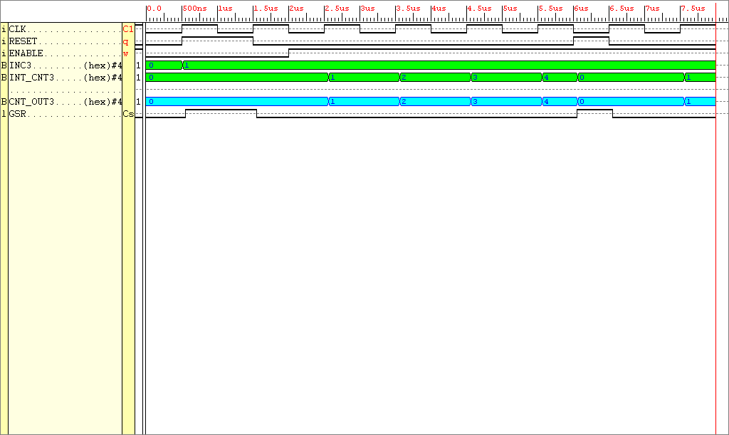
Figure34: Simulation results gathered from the implemented entity Counter

Notice the output of the counter is four bits wide, this may need to be changed after initial testing, maximum count available with this counter is 15. Knowing the entity performed true to it’s design it was then placed and routed using the Xilinx Foundation Software. This allowed further analysis such as FPGA routing constraints, and physical size determination. The Counter entity required 4 complex logic blocks. There is one more item required by the DSP, and that is the seven segment display decoding entity.
The seven segment encoder is required to fetch and decode the processing count and the value of each element of the 3x3 answer product matrix in turn. To output the matrix answer and the number of processing clock cycles to the seven segment displays would require many outputs. As analysed on page 43, the maximum magnitude an element of the matrix product can be is 27. 27 is a two digit number, 2 seven segment displays would be required to display this number. Hence 18 seven segment displays are required to display the 3x3 matrix product plus 1 or 2 displays for the processing count, maximum total displays required, 20. 20 seven segment displays alone require 280 (20 x 14) inputs. The FPGA has a maximum of 63 outputs available; a compromise must exist between FPGA outputs and number of seven segment displays outputted to. One segment of the matrix product should be outputted at a time. Hence 14 outputs from the FPGA are required in order to generate the matrix product segment , 10 clock cycles and 10 different select input signals would be required to output the full answer. What hasn’t been explained yet is how the seven segment display data will get to it’s correct destination on the seven segment display board, this will be explained later. The behaviour model of Entity Seven_Seg_Enc can be viewed in the appendix of this report.

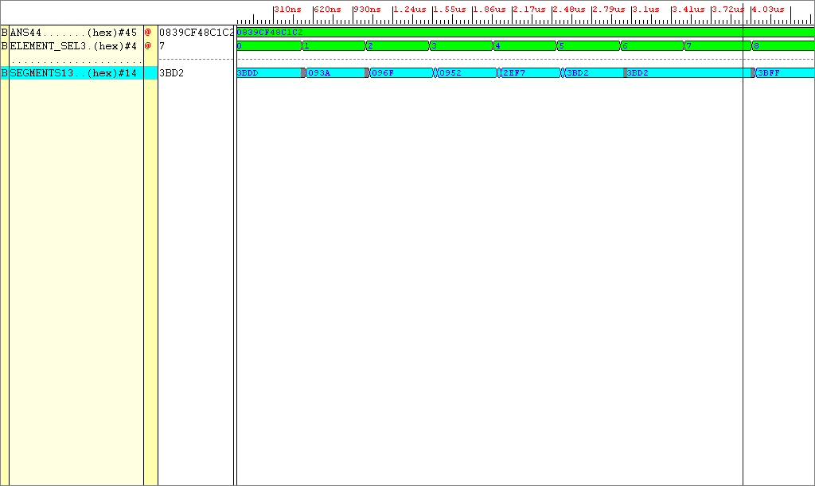
Figure35: Simulation Results from ENTITY Seven_Seg_Enc

The test pattern shown as applied to the input ANS was 8 7 7 7 20 17 16 14 2, each of these digits are five bits wide, each number represents an element of the product matrix (hence the number 2 will be bit extended i.e. padded zeros will be placed in front of it’s binary equivalent).

Decimal test pattern data 8 7 7 7 20 17 16 14 2
Binary (5bit) conversion 01000 00111 00111 00111 10100 10001 10000 01110 00010
Binary (4bit) grouping 0.1000.0011.1001.1100.1111.0100.1000.1100.0001.1100.0010
Hexadecimal conversion 0839CF48C1C2

The test pattern is then converted to hexadecimal equivalent. The result is shown on the simulation input as 0839CF48C1C2. Dependant on the ELEMENT_SEL value (10 selections, 4bit select signal), 1 of the 10 segment values will be outputted in seven segment display encoding. The output in blue refers to the hexadecimal value (a 14bit binary value) required to stimulate two seven segment displays. Knowing the entity performed true to it’s design it was then placed and routed using the Xilinx Foundation Software. This allowed further analysis such as FPGA routing constraints, and physical size determination. The Seven_Seg_Enc entity required 95 complex logic blocks.
The total number of CLB’s required for the DSP in total is

Data_Store : 6 CLB’s
Multiplier : 54 CLB’s
Adder : 54 CLB’s
Answer_Store : 23 CLB’s
Counter : 4 CLB’s
Seven_Seg_En : 95 CLB’s
Total : 237 CLB’s

There are a total of 400 CLB’s available on the XC4010XL PC84 FPGA, which means only 163 CLB’s are available for the finite state machine.
With all the DSP completed, the finite state machine can now be created. Before delving straight into it’s design lets look at a high level view of the whole system thus far. The finite state machine will then be built round these DSP parts.
RESET
CLK
RESET
CLK
SELECTS ONE ELEMENT PRODUCT
14 DATA
SIGNALS
SENT TO TWO
7-SEG DISPLAYS
10 7-SEG DISPLAY ENABLING SIGNALS
ANSWER OUTPUT ENABLE
8 INPUTS
External CLK, data and select lines

FSM

Data Store

Multipliers

Adders

Counter

Answer Store

Seven Seg Enc
COUNT_OUTPUT
MODE
SELECT
SIGNALS

Figure 36: Conceptual view of the 3x3 matrix multiplier system
The FSM controller will be made to operate in 8 different modes, controlled via an 8-bit set of inputs i.e. 4 modes are used for parallel manipulation, the remaining 4 are used for serial operation. But which multiplying operations could this system perform:-

Remember Matrix_A will multiply happily with Matrix_B IF the number of columns in Matrix_A equals the number of rows in Matrix_B.

The following matrix multiplications have been chosen at random from the available matrix multiplications for matrices with dimensions 3x3 and smaller.

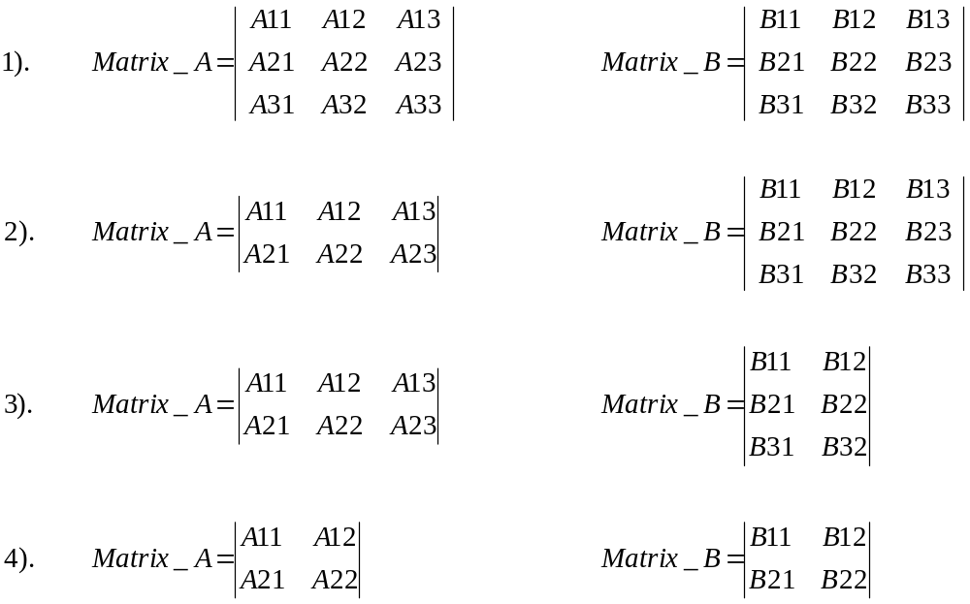

How’s the processing power of the system going to be measured using the serial mode?

An entity is needed in-between entities Data_Store and Multipliers. This entity will select the input data in accordance with the finite state machine mode select signals. Hence when serial mode is selected the data from this entity called “Inter_Store” outputs the element coefficients one at a time, hence in the worst case 18 clock cycles will be required to achieve the answer serially for two 3x3 matrix multiplications.

Instead of having 8 mode select signals input to the Finite State Machine, have 5, Why?

One input selects either the serial or parallel multiplication mode. The other four inputs select what size matrices are to be multiplied.
For the entity Inter_Store to operate require DECIMAL “19” selects. 19 requires five binary digits. Hence this entity requires a CLK, RESET, 36-bit inputs, a 5-bit select and a 36-bit output. Fingers crossed, hope this ENTITY doesn’t take up too much FPGA space.

This is a description of how this ENTITY works, the brains are used in the selection of data. If parallel mode is selected, all data will be outputted from the entity in parallel. If serial mode is selected, then dependant on what mode of matrix operation is selected, data will be outputted from the device in a serial nature. If the matrices in question are of a small size, then less clock cycles are required to pass all of it’s data onto arithmetic logic. The behaviour model of Entity Inter_Store can be viewed in the appendix of this report.
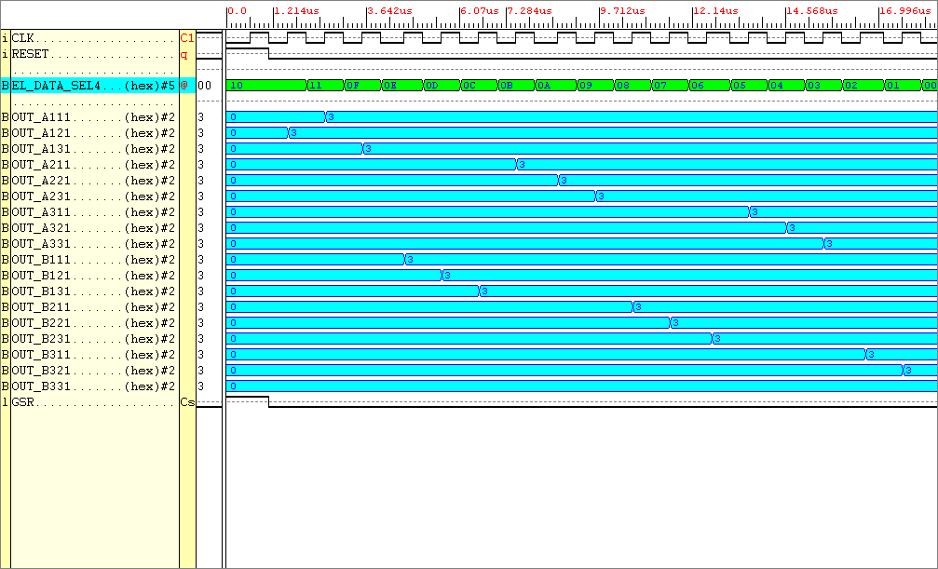
Figure37: Simulation results for the Entity INTER_STORE

Looking at the results above. It can be seen (the input signals are not shown but there are 18 of them) when the data_select signal is in the region 0 to 17 one of the inputs is outputted. When data_select(17) is chosen all the data is outputted in one instance. Knowing the entity performed true to it’s design it was then placed and routed using the Xilinx Foundation Software. This allowed further analysis such as FPGA routing constraints, and physical size determination. The Inter_Store entity required 63 complex logic blocks.
Figure 36 can now be updated to include the this new information derived from further analysis of the DSP components.

DATA SELECT
10-BIT
7-SEG DISPLAY ENABLING SIGNALS
CNTR_EN SIGNAL (1-bit)
RESET
CLK
RESET
CLK
SELECTS ONE ELEMENT PRODUCT (4-bits)
14 DATA
SIGNALS
SENT TO TWO
7-SEG DISPLAYS
5-BIT MODE
SELECT
SIGNALS
ANSWER OUTPUT ENABLE (1-bit)
8 INPUTS
External CLK, data and select lines

FSM

Data Store

Multipliers

Adders

Counter

Answer Store

Seven Seg Enc
COUNT_OUTPUT

Inter
Store
RESET
CLK
RESET

Figure38: Update of the complete system (Red arrows signify, connected outside FPGA).
A test will now be run on the DSP, the matrix data used is shown below
0
1
2
1
3
2
1
3
2
3
2
3
0
2
1
1
3
1

MATRIX_A MATRIX_B

The data needs to be input to the system in 3-bit chunks. Taking Matrix_A data to begin with, writing down each elements data in a row by row basis, followed by Matrix_B data, we have.

10 01 00 11 10 01 01 11 10 11 00 11 10 01 10 01 11 01

Split the data into 3-bit entities we have

3-bit
block Index 11 10 9 8 7 6 5 4 3 2 1 0
Bit steam
100
100
111
001
101
011
110
100
011
110
110
011
Integer Value 4 4 7 1 3 6 6 3 4 6 3 5

The Product Matrix is calculated below:-

(2 x 3) + (1 x 2) + (0 x 1) = 8
(3 x 3) + (2 x 2) + (1 x 1) = 14
(1 x 3) + (3 x 2) + (2 x 1) = 11

(2 x 0) + (1 x 1) + (0 x 3) = 1
(3 x 0) + (2 x 1) + (1 x 3) = 5
(1 x 0) + (3 x 1) + (2 x 3) = 9

(2 x 3) + (1 x 2) + (0 x 1) = 8
(3 x 3) + (2 x 2) + (1 x 1) = 14
(1 x 3) + (3 x 2) + (2 x 1) = 11

The DSP does work correctly. Shown below are the outputs from the system corresponding to element select signal (shown in Figure 38):-

Element Product Select 7seg Data Sig(hex) Number displayed

9 3BFF 8 --ELEMENT 1
8 093A 14 -- ELEMENT 2
7 0912 11 -- ELEMENT 3
6 3B92 1 -- ELEMENT 4
5 3BEB 5 -- ELEMENT 5
4 3BFB 9 -- ELEMENT 6
3 3BFF 8 -- ELEMENT 7
2 093A 14 -- ELEMENT 8
1 0912 11 -- ELEMENT 9
0 3BDB 3 -- COUNTER ELEMENT

To view the tests performed on the full range of matrices please refer to the appendices.

The Finite State Machine
In order to signify to the finite state machine “data has now been loaded into the data store entity now act upon it,” there must be a signal between these two entities in order to communicate this information. A one bit output from the ENTITY Data_Store to the FSM will be used, that flags “ready to start computing,” this signal will be called Start_Com. This will now need to be implemented by the Data_Store Entity, DSP Entity, and used as an input to the matrix state machine.
The MATRIX MODE INPUT (5-bits) tells the system how to handle the incoming element data, there are 4 modes available.
- IF two 3x3 matrices are being multiplied together then the matrix mode MUST be set to BIN 11000, HEX 18 (FULL PARALLEL MULTIPLICATION) OR BIN 01000, HEX 08 (FULL SERIAL MULTIPLICATION), the most significant bit stipulates the mode of operation either parallel ‘1’ OR serial ‘0’.
- IF a 2x3 matrix is being multiplied by a 3x3 then the matrix mode MUST be set to BIN 10100, HEX 14 (FULL PARALLEL MULTIPLICATION) OR BIN 01000, HEX 04 (FULL SERIAL MULTIPLICATION), the most significant bit stipulates the mode of operation either parallel ‘1’ OR serial ‘0’.
- IF a 2x2 matrix is being multiplied by a 2x2 then the matrix mode MUST be set to BIN 10001, HEX 11 (FULL PARALLEL MULTIPLICATION) OR BIN 01001, HEX 01 (FULL SERIAL MULTIPLICATION), the most significant bit stipulates the mode of operation either parallel ‘1’ OR serial ‘0’.

The 5-bits allowed for the mode select signal is over specified, this could easily be scaled down. Remembering that the MSB selects the serial or parallel mode operation, the other 4-bits select the 4 types of matrix multiplications, this could easily be done using 2-bits. Hence a maximum of 3-bits are required to select the correct multiplication mode. The lower 2-bits of the select signals will also be input to the data store entity. Because the matrix multiplication select mode is known, the Data_Store Entity can with a minimal amount of control lines select the correct data to be sent to the Entity Inter_Store. Now the basic ideas have been laid down, the behaviour of the entity can now be analysed. The behaviour model of Entity Finite_State_Machine can be viewed in the appendix of this report.

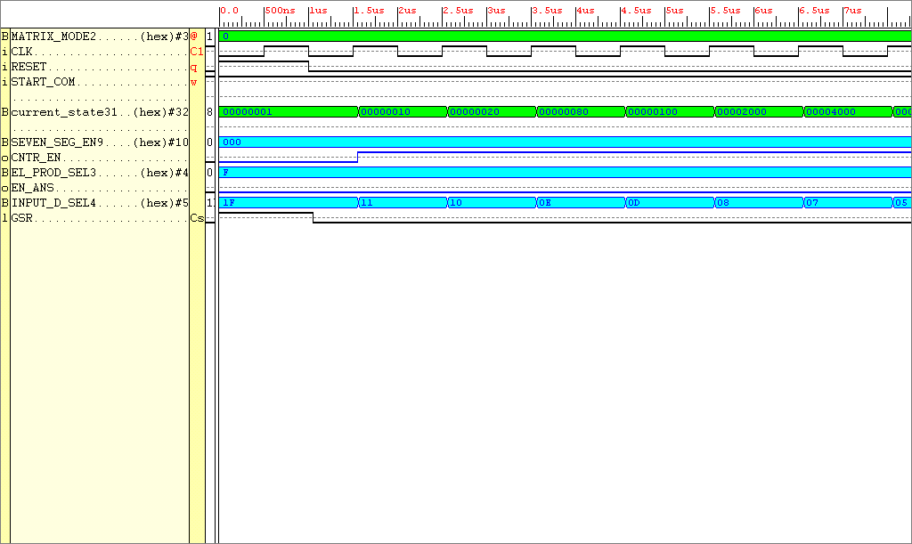
Figure

The finite state machine inputs data from the data store in accordance with the matrix mode. In this particular example the select signals indicate serial data processing. The counter is enabled in the second state that counts the amount of clock cycles required to process the data. Once all the data has been inputted (with input START_COM enabled), a seven segment display enable signal is outputted with it’s corresponding seven segment display data. Knowing the entity performed true to it’s design it was then placed and routed using the Xilinx Foundation Software. This allowed further analysis such as FPGA routing constraints, and physical size determination. The Finite_State_Machine entity required 44 complex logic blocks.

ENTITY Config_Inf

A simple explanation for this entity is as follows:

- If Reset is high output an ‘R’ on the seven segment display
- Else if Start Com is high output a ‘C’ on the seven segment display
- Else look at the value on the Matrix Mode and output that value to the seven segment display
The behaviour model of Entity Config_Inf can be viewed in the appendix of this report.
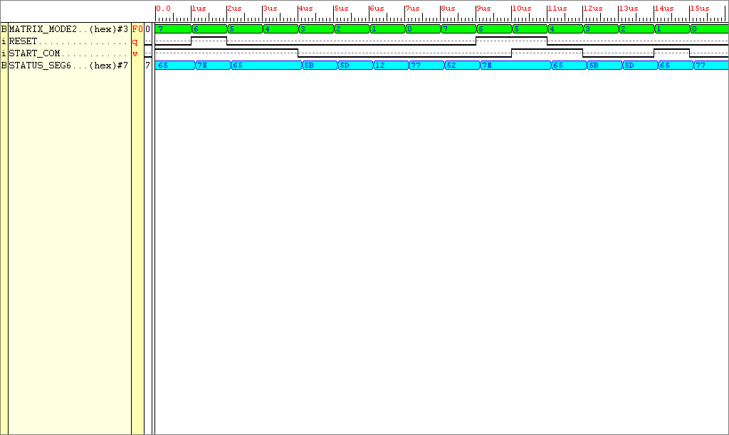

FigureX Simulation results taken from the Xilinx Foundation Verification Tool for the entity Config_Inf

Great, this entity will give information regarding how the system is configured and if the starting flag is being sent to the finite state machine.

